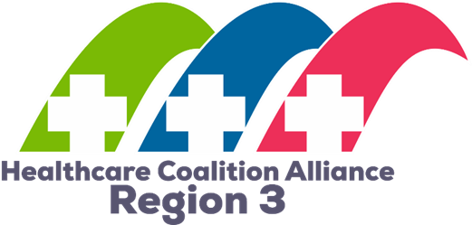
2023
Region 3 Healthcare Coalition Alliance
Region 3 Alliance Preparedness Plan
Adopted May 2018
Update Approved March 2023
Preparedness Plan

Introduction
The Northeast Florida Healthcare Coalition (NEFLHCC) was organized in early 2014 representing six counties (Baker, Clay, Duval, Flagler, Nassau, and St. Johns Counties). Those six counties along with four discipline group partner members (Public Health, Emergency Management, Hospital, and Emergency Medical Services) make up the Board of Directors. The NEFLHCC saw tremendous membership growth in 2017 and expanded the Board to include two ‘At Large’ Members, representing Long Term Care and Allied Health (Home Health, Dialysis, Ambulatory Surgery Centers, Durable Medical Equipment Providers, Pharmacies, etc.). The surge in membership can be attributed to an increase in outreach activities and the implementation of the CMS Rule for Emergency Preparedness, which encourages healthcare providers to seek out their Healthcare Coalitions.

The North Central Florida Healthcare Coalition (NCFHCC) serves Alachua, Bradford, Columbia, Dixie, Gilchrist, Hamilton, Lafayette, Levy, Putnam, Suwannee, and Union counties. The Board consists of seven members, three at large members, and four discipline representatives from Public Health, Emergency Management, Hospitals, and EMS.

The Marion County Coalition for Health and Medical Preparedness (CHAMP) is a collective, independent voice of individuals and public, private, professional, and non-profit organizations, services, citizen groups, and businesses, working together in emergency preparedness all hazards that impact the health and medical systems within Marion County.

The creation of the Region 3 Healthcare Coalition Alliance took place in 2017. This was the structure created in response to the simplified contracting process put in place by the Florida Department of Health (FDOH), allowing for only one contract to be written per region. Region 3, as defined by FDOH, included three established healthcare coalitions:
  - Northeast Florida HCC,
  - North Central HCC, and
  - the Coalition for Health and Medical Preparedness (CHAMP).

The formation of the Alliance provides oversight to the funding while allowing the three coalitions to maintain their individual missions within their unique geographic and demographic healthcare community. Each healthcare coalition has Bylaws that identify and inform the member’s roles and responsibilities. The Region 3 Healthcare Coalition Alliance Bylaws and the Alliance Operational Plan provide additional information on each coalition’s roles and responsibilities.

Purpose
The Region 3 HCC Alliance Preparedness Plan establishes and describes the roles and responsibilities of the Coalition in the five mission areas of the National Preparedness Goal – Prevention, Protection, Mitigation, Response, and Recovery. This plan works in coordination with other Coalition plans, including the Strategic Plan, which establishes the goals and objectives for each of the four ASPR-defined Health Care Preparedness and Response Capabilities. Additionally, the Region 3 Healthcare Hazard Vulnerability Assessment (HVA) and the Region 3 Healthcare Risk Assessment (JRA) frame the risks to the 18-county regional healthcare system. Collectively, these plans define the work of the Alliance and its member Coalitions.

Scope
This Preparedness Plan supports the short and long-term objectives defined in the Strategic Plans for the CHAMP Coalition, Northeast Florida Healthcare Coalition, and the North Central Florida Healthcare Coalition. These objectives were developed with full coordination of member organizations and based on hazards faced and gaps identified in relevant planning documents across the 18 counties within Region 3. The Preparedness Plan addresses those issues that are experienced across the 18 counties in Region 3, to allow for effective coordination and collaboration in preparedness and to efficiently recover from an emergency.

The real-world events and experiences from the 2022 hurricane season and the 2020-21 response to COVID-19 allowed the Coalitions and all of Region 3 to better understand the risk and the extent of the needs for the healthcare community during a natural disaster and/or public health emergency. This plan is reviewed and updated annually.

administrative support
The Region 3 Alliance Preparedness Plan and all supplemental, supporting plans are presented to each healthcare coalition board for review and input following guidelines outlined in the Bylaws. Comments and feedback from members are analyzed and included in the final document presented to each Board for annual approval. This Preparedness Plan is considered a “living document,” in that it is subject to an annual review and revision based upon recommendations following any type of test of the plan or change in State or Federal guidelines.

The final plan is provided to all Board members for approval annually at the March meeting. A copy of the approved plan is posted on the Coalition Alliance website (www.FLRegion3HCC.org) for use by Coalition members.

Coalition Overview

Introduction/Role/Purpose of Coalition
The development and sustainment of HCCs is a federal initiative and a requirement of the Hospital Preparedness Program (HPP) Cooperative Agreement funded by the Administration for Strategic Preparedness and Response (ASPR). The purpose of HCCs is to ensure that local providers and other healthcare partners plan collaboratively for the risks facing the healthcare community and identify available local resources.
Healthcare Coalitions have been defined as “a collaborative network of healthcare organizations and their respective public and private sector response partners that serve as a multi-agency coordinating group to assist with preparedness, response, recovery, and mitigation activities related to healthcare organization disaster operations.”—Healthcare Preparedness Capabilities: National Guidance for Healthcare System Preparedness.
Each Coalition within Region 3 has developed a specific mission or purpose. For the Northeast Florida Healthcare Coalition, the mission developed in 2014 remains relevant in the state of the world today – “Achieve a health and medical system that is efficient and resilient in an emergency”. This is done through membership of core partners in the public health, emergency management, hospital, EMS, Long Term Care, and Allied Health disciplines. This multi-jurisdiction membership will grow, flex, and expand to meet the challenges of today’s world and in the future.
The mission of the North Central Florida HealthCare Coalition (NCFHCC) is to coordinate healthcare system preparedness and resilience through all sectors of the healthcare system. Response activities are managed through existing Emergency Support Function (ESF) 8: Health and Medical structures within local jurisdictions as defined in each member county’s Comprehensive Emergency Management Plans (CEMP). While not a response entity, NCFHCC members serve a multi-jurisdictional and multi-agency function to coordinate actions and resources during a response, based on the networks built through the Coalition process. It is also recognized that NCFHCC activities will serve to enhance and expand local ESF 8 Health and Medical and regional response capabilities and capacities.
The Marion County Coalition for Health and Medical Preparedness (CHAMP) mission is to be an independent voice of public and private partners working together in emergency preparedness for all-hazards that impact the health and medical systems.

Coalition Boundaries
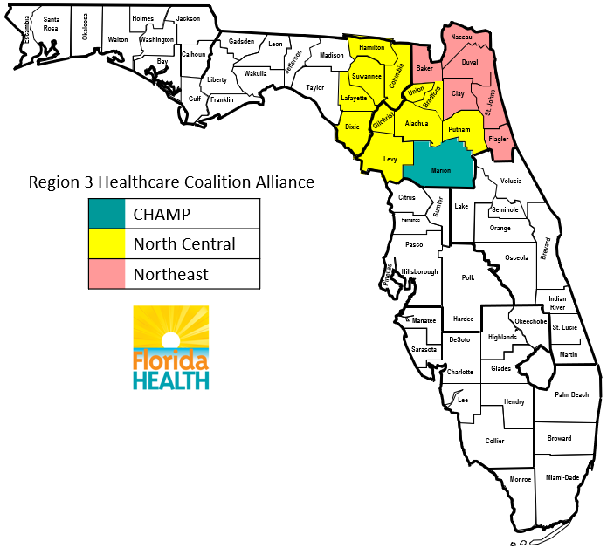

Coalition Members
Each Coalition contains the core member groups as defined by ASPR: Emergency Management, Public Health, EMS, Acute Care Hospitals, and Assisted Living Facilities. Each Coalition continues to grow in these areas, most specifically among the “Long Term Care” facilities and “other” healthcare provider types. This is a continued objective of the Coalitions – to increase membership, including leadership of hospitals and healthcare facilities.

Organizational Structure/Governance
Each Coalition is structured slightly differently, with a varying number of Board members. Each Coalition is governed by Bylaws and Charter documents. However, the Region 3 HCC Alliance has its own structure as defined in the Region 3 Healthcare Coalition Bylaws. The Chair of the Alliance Board is the Department of Health- Health and Medical Co-chair. The Chair is a non-voting member. The remaining Board of the Alliance will be made up of the three members of each Coalition. The Chair and Vice Chair of each Coalition are permanent members of the Alliance Board, and the third member is a Member at Large from each Coalition, who shall be selected by each Coalition. Each Coalition has a single vote on the Alliance. The Alliance strives to maintain a diverse Board, with representation from all disciplines the Coalitions represent.

Role of Leadership within Member Organizations
The bylaws for each coalition include provisions for attendance and participation at Coalition meetings. But more importantly, numerous opportunities exist for members to engage in the work of the Coalition. Opportunities include working groups, exercise planning teams, and subject matter expert roles at events. This allows members to better understand the important role the Coalition plays in the Region and gives ownership in shaping the activities of the Coalition to meet members’ needs.
A noted gap across the three Coalitions is the engagement of healthcare facility executive leadership. Preparedness planners, safety officers, disaster coordinators, etc. recognize the valuable opportunities the Coalition provides and actively participate in their agency and/or facility. The Coalition’s value is not fully appreciated by the leadership of most facilities in the C- Suite. This is an objective identified in the NEFLHCC Strategic Plan as well as the Alliance’s Strategic Plan.

Risk
The hazard identification and analysis sections from member Counties’ Comprehensive Emergency Management Plans (CEMP) serve as the local jurisdictions’ foundation for all-hazard emergency planning, training, exercise, and resource allocation. Consequently, the data and information presented in these documents are considered current and along with other data sources, were used to build the Region 3 Healthcare Hazard Vulnerability Assessment and Jurisdictional Risk Assessment.

The hazard ranking priorities outlined in the Region 3 Alliance Healthcare HVA/JRA are:
Region 3 Healthcare Hazards
Level of Risk | Hazard
Major | Hurricane / Tropical Storm (including storm surge)
Major | Regional Electrical Failure (i.e., blackout)
Major | Flooding with potential for disruption / harm (Includes Sea Level Rise)*
Major | Cyber Terrorism
Major | Infectious Disease
Major | MCI Incident General Injuries
Moderate | Regional Communications Disruption
Moderate | Multi-Jurisdictional Wild Fire
Moderate | Widespread Supply Chain Interruption
Moderate | Armed Individual/Active Shooter incident (Large Scale)
Moderate | Tornado or Microburst
Moderate | Pandemic
Moderate | Multiple Facility Evacuations
Moderate | Regional Sewer / Water Treatment Failure
Moderate | Regional Water Disruption / Interruption
Moderate | MCI involving chemical, biological, or radiological materials
Minor | Widespread Transportation Disruption / Failure
Minor | Regional Fuel Shortage(s)
Minor | Temperature Extremes
Minor | MCI involving conventional weapons
Minor | Winter Weather Event
Scoring matrix and detailed criteria on the ranking of these hazards can be found in the Region 3 Alliance Healthcare Hazard Vulnerability Assessment/Jurisdictional Risk Assessment.

Gaps
The Florida Public Health Risk Assessment Tool (FPHRAT) includes jurisdictional risk assessments that identify potential risks within the community relating to the public health, medical, and mental/behavioral systems, inclusive of at-risk individuals. Gaps are identified in this tool. This and other data were used to develop the Region 3 Jurisdictional Risk Assessment for Healthcare.
Additional resources are used by the Coalitions to identify gaps, including reliance on After Action Reports (AAR) completed after exercises or real-world events.

Compliance Requirements/Legal Authorities
The Coalitions in Region 3 are bound by the terms of the contract with the Florida Department of Health. This includes authorities as found in Sections 252.35(2) (a) 3 and 381.0011(7), Florida Statutes.
Healthcare Coalitions in collaboration with the ESF-8 lead agency and state authorities must meet regulatory compliance requirements that are applicable to day-to-day operations and may play a role in planning for, responding to, and recovering from emergencies.
The Coalitions are working diligently to better understand the CMS Rule for Emergency Preparedness and how it affects member organizations. The Coalition is working to provide data, as needed, for facilities as they create their required plans and procedures. The Coalition also works with the First Coast Disaster Council, an organization representing the hospitals in Northeast Florida, on their relevant Joint Commission requirements as they pertain to exercises. When planning, designing, and implementing exercises for Coalition members, the staff is cognizant of all relevant accreditation standards and works to address as many as possible. There is room for growth in this area, as more facilities are surveyed for these new standards, the Coalition will better understand the needs of the members in this regard.

Coalition Objectives
The Coalition’s strategic plans reflect the structure of the Coalitions within Region 3, the ASPR Health Care Preparedness and Response Capabilities (2019-2024). Short-term objectives/Strategies include Membership; Sustainability; Gap Filling; and Healthcare Executive Engagement. Long-term Objectives/Strategies include Coalition Role in Response and Crisis Standards of Care. Objectives and Strategies for the Alliance include Strengthening the working relations between NEFLHCC, NCFHCC, and CHAMP and determining the functionality of an 18-county coalition.

Workplan
Each Coalition of the Region 3 Alliance has Membership from the following disciplines. Across each Coalition, members have similar roles and responsibilities.

Coalition Members Roles and Responsibilities
- County Departments of Health
Departments of Health (DOH) have the lead role in coordinating public health in their respective county. Each DOH has developed all-hazards response plans and can implement these plans on short notice. Additionally, DOH plays the lead agency in most counties Emergency Support Function (ESF) 8 during a County activation. DOH is represented on all Healthcare Coalition Boards and functions as a subject matter expert on all matters regarding public health, including highly infectious diseases, special needs sheltering, and statewide health and medical issues.
- County Emergency Management Offices
Local emergency management activities are coordinated by County Emergency Management offices (EM). County EM coordinates regionally, as needed, and provides leadership in all aspects of preparedness, response, recovery, and mitigation for their citizens and agency partners. Local EM is represented on all Healthcare Coalition Boards.
- Hospitals
Hospitals are critical partners in healthcare coalitions, as they are responsible for providing definitive care to individuals resulting from a disaster or other medical emergency. Hospital emergency operation activities include preparing for medical surge incidents, as well as activating and staffing alternative care sites and extended care sites. Coalitions work closely with hospitals to assist in meeting their annual training and exercise requirements for accreditations.
- Emergency Medical Services Agencies
Emergency Medical Services agencies (EMS), both public and private, are responsible for providing varied types of transport for a variety of patients, including during times of disaster. EMS agencies are critical partners for medical surges, healthcare evacuations, and mass casualty response operations.
- Long Term Care/Assisted Living/Residential Care
Long-term Care, Assisted Living and Residential Care are all interchangeable terms. There are differences in the level of care provided to the residents i.e., medical (ex. Long-term Care) versus nonmedical (ex. Residential Care). The types of assistance provided during a disaster will vary depending on the facility and its number of beds. Most likely these types of facilities can place patients in evacuating facilities if needed. The Coalition works with these facilities for training and exercise opportunities to meet various accreditation requirements, focusing on the newly implemented CMS Emergency Preparedness Rule.
- Home Health Agencies
Member home care agencies provide support to the healthcare continuum of care by continuing to provide the delivery of care during disasters for individuals able to shelter in place within their own homes. Additional coordination with home health agencies is ongoing to coordinate a role for these agencies in special needs sheltering operations and in helping to prepare their patients for hurricane season and assembling an evacuation plan.
- Allied Health
In addition to the acute-care hospitals, there are skilled nursing facilities, standalone emergency rooms, community health centers, dialysis centers, and numerous tertiary care facilities in the region. Skilled nursing facilities (SNF) and other allied healthcare entities are being integrated into the coalition, as they have an important role in the response and recovery to disasters. In addition, with greater participation in the Coalition, these facilities can be better supported in the event of an isolated incident affecting their operations.
Numerous plans and documents have been developed over the past several years by Coalitions to quantify their role and the role of the Coalition members during a disaster, including documenting communication, resources, and information-sharing procedures in the region and the operational role of the Healthcare Coalition.

